**App & Web Server**

**Name: Rakesh – 15**

1. Install nginx and run nginx on port number 81.

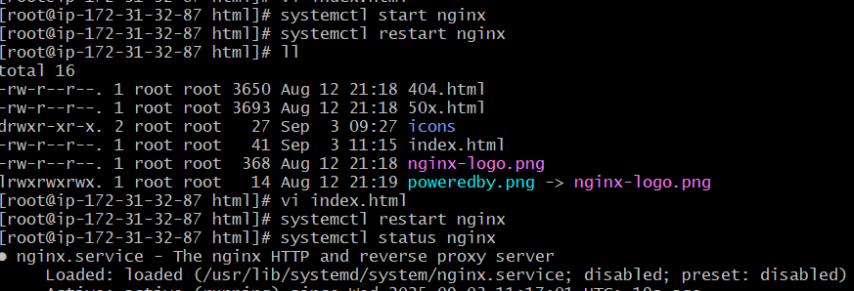

* Yum install nginx
* Systemctl start nginx
* Systemctl restart nginx
* Systemctl status nginx

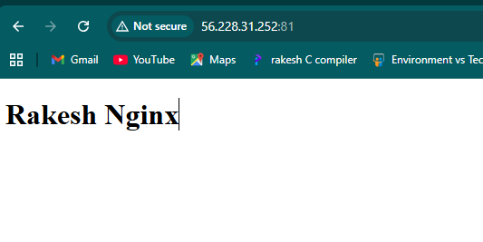

* After giving the port no.81
* Copy the ipv4:81 refresh the window

1. Deploy a sample index.html file on nginx.

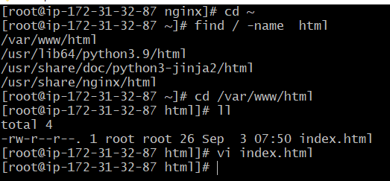

* Find the directory of nginx
* Create a file with index.html

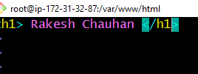

* Give the text on vi index.html and save
* Ask permission using chmod 755 f1
* Print output ./index.html

1. Install Apache and run Apache on port number 82

* Yum install httpd
* Systemctl status httpd
* Systemctl start httpd
* 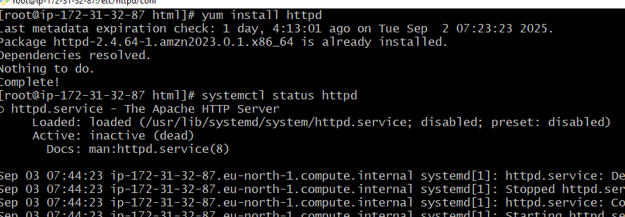Give the port no.82
* Copy the ipv4:82 refresh the window



1. Deploy a sample index.html file on Apache.

* Change the directory to /var/www/html
* Create a zero byte file with index.html

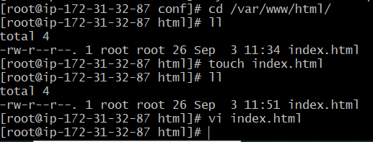

* Give the text on vi index.html and save
* Ask permission using chmod 755 f1
* 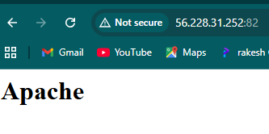Refresh the page

1. 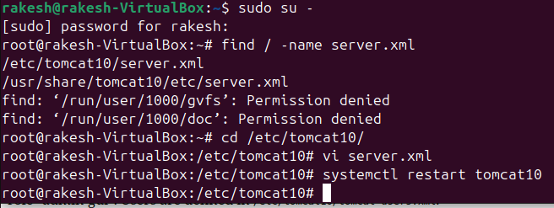Install Apache tomcat on port number 8082

* Install tomcat10 VM
* Create a file server.xml & add the data on it, Copy the port.no:8082 and refresh the page

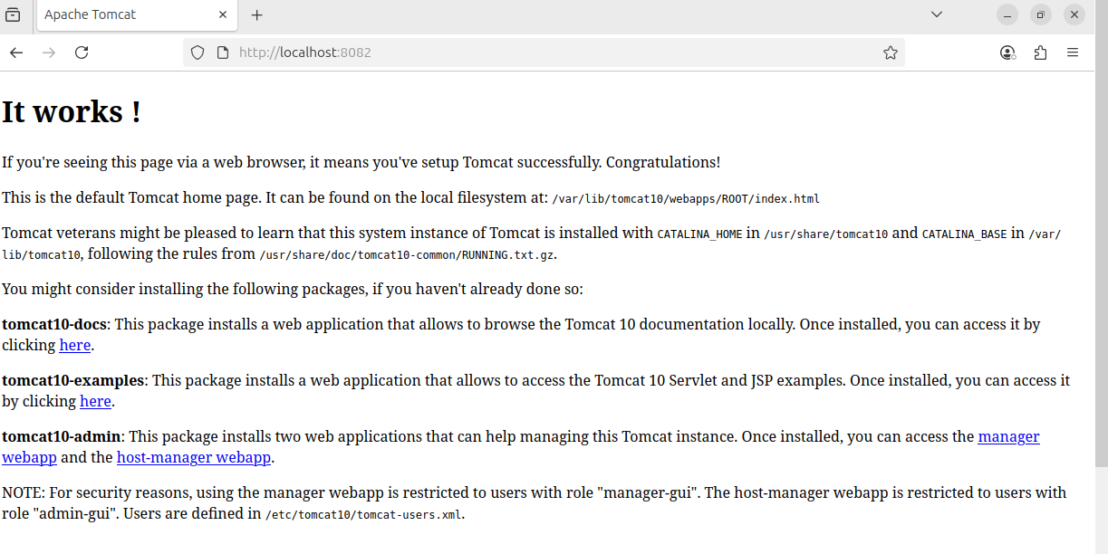

1. Deploy a sample app on webapps.

* Take a sample application webapp and copy the link
* Paste the wget webapp link and install it
* Extract the file sample.war

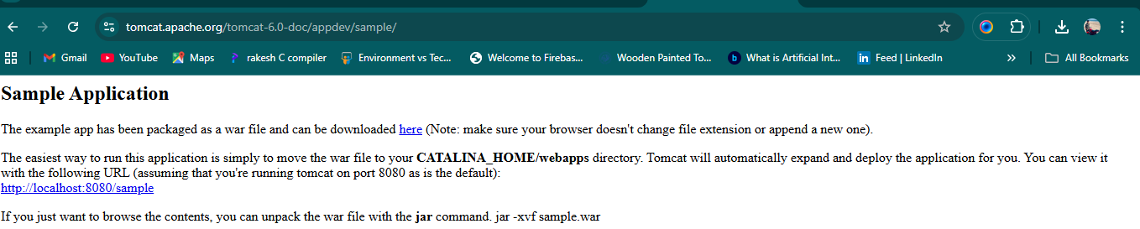

* Copy the IPV4 portno:8080 and refresh the page

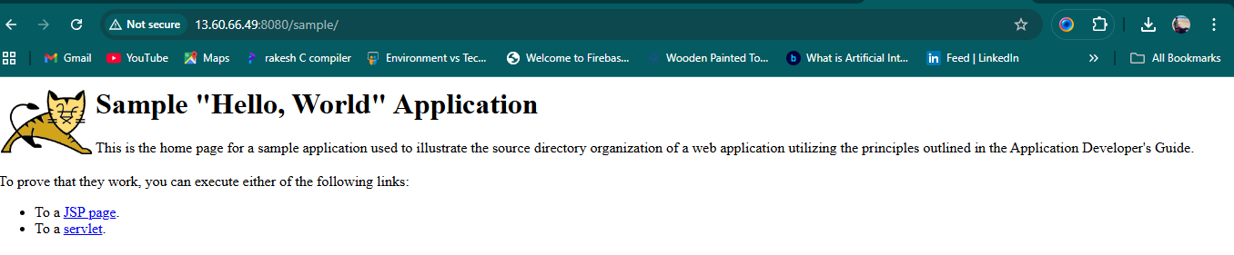

1. Create a Tomcat.Service file for Tomcat.

* Create tomcat.service in /etc/system/system/



* 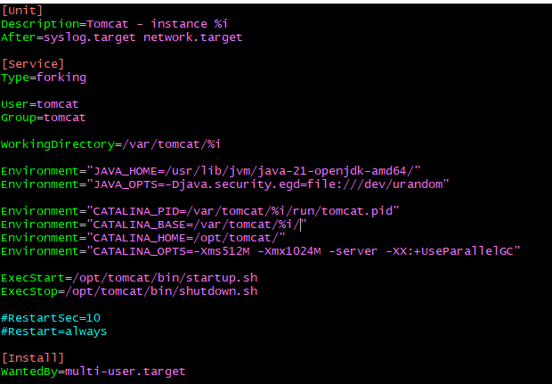Enter service configuration data in tomcat.service file
* Save and reload by using systemctl daemon-reload command to recognize new service file

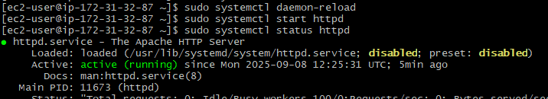

8) Configure HA Proxy server

* Yum upgrade
* Yum install nginx
* Systemctl start nginx
* Systemctl stauts nginx
* Find / -name nginx
* Cd /etc/nginx
* Ls
* Vi /etc/nginx/nginx.conf
* Systemctl restart nginx
* Systemctl status nginx
* 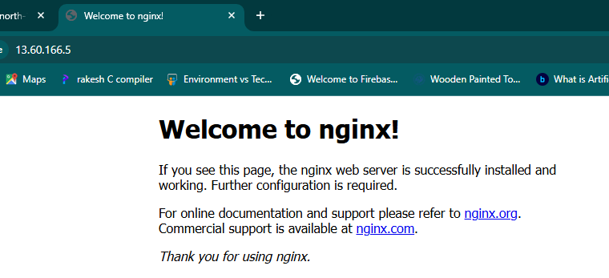Change the IPV4:80 in AWS instance & Refresh the browser
* Yum upgrade
* Yum install httpd
* Systemctl start httpd
* Systemctl status httpd
* Paste the IPV4:80 on browser and refresh it